**ASSIGNMENT 32.2**

**QUESTION : Integrate Hbase with Hive**

**● Load Data (Bulk Load) from Hive table to Hbase Table**

**● Explain the procedures and code implemented with screenshots.**

**● Note: Candidates should Load their own data into Hbase table.**

**STEP 1: Create the table “custom1” and loading data into it in HIVE**

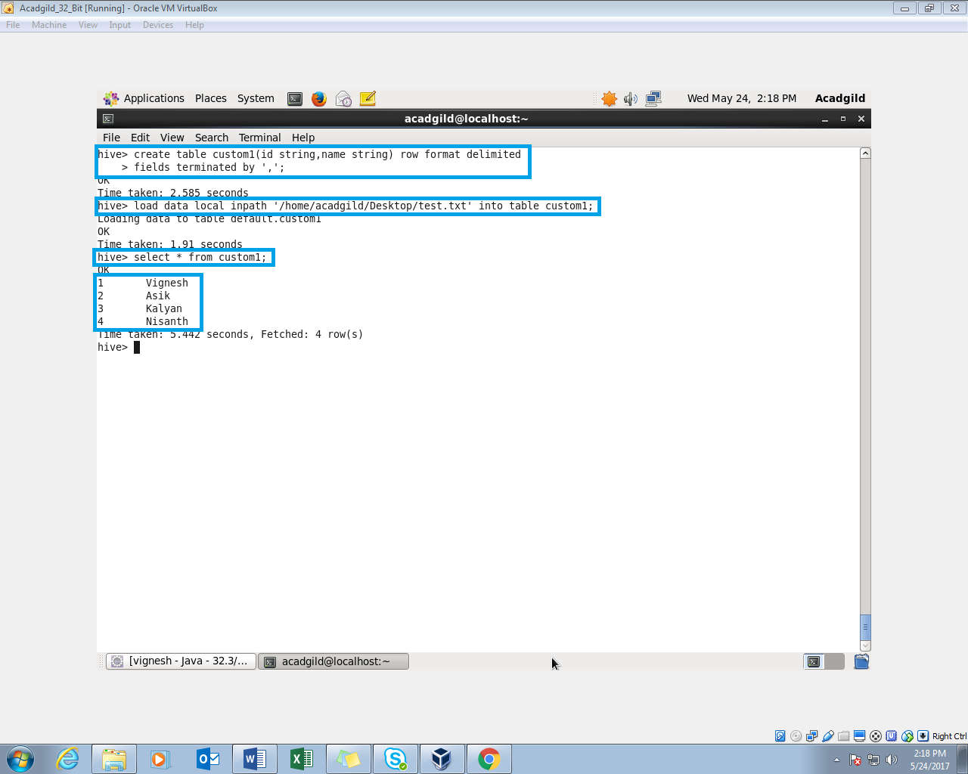

**Step 2: Create a table ‘customer1’ with details as column family in HBASE**

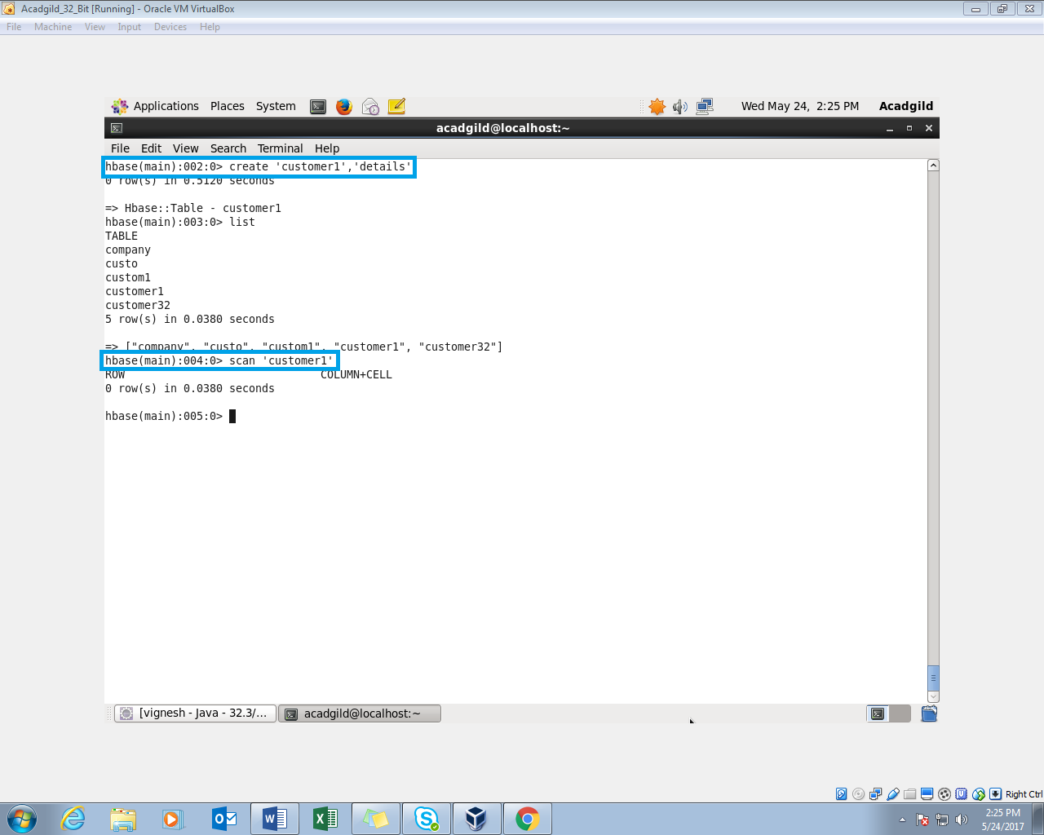

**STEP 3:**

**Create external table and load data into it from hive**

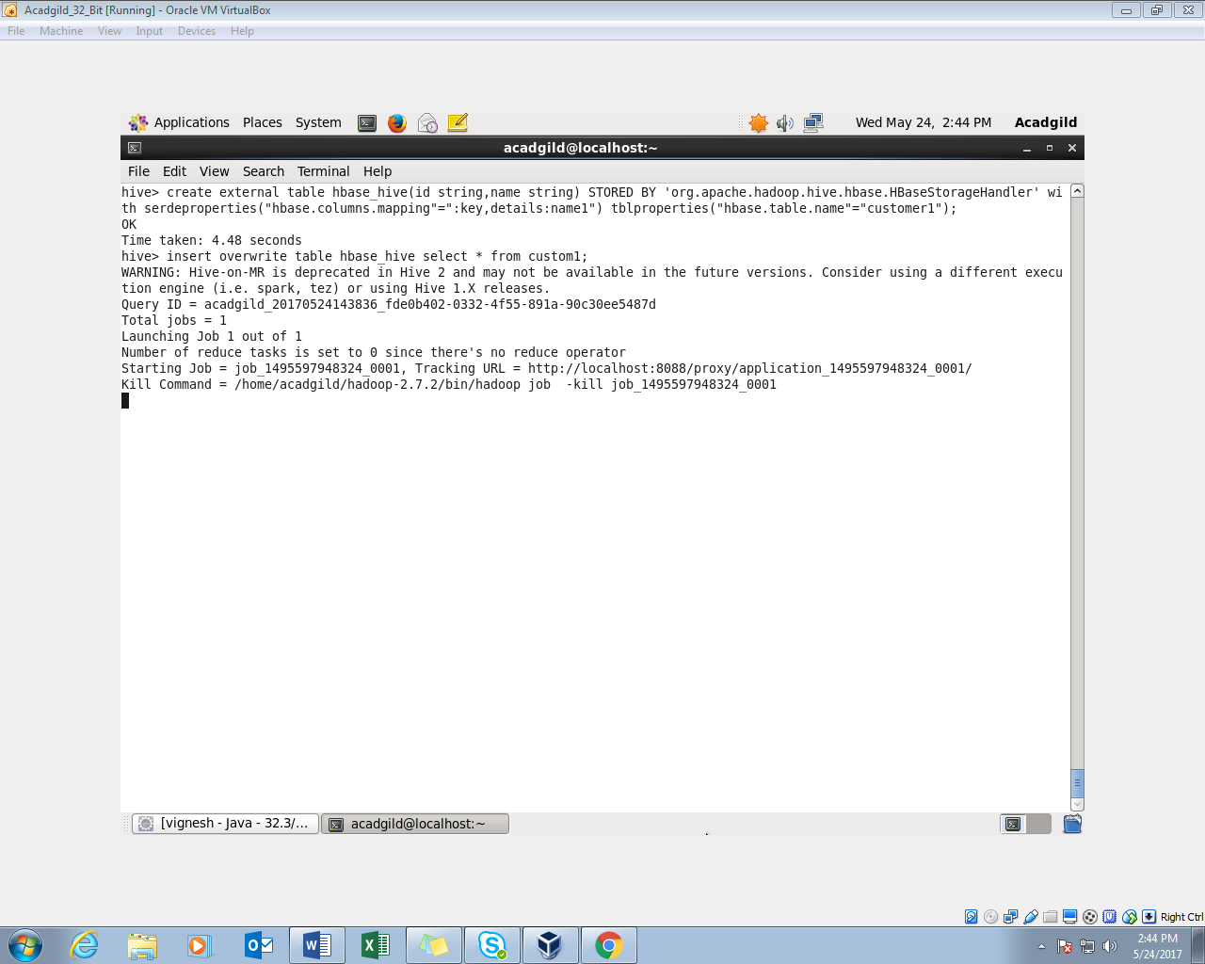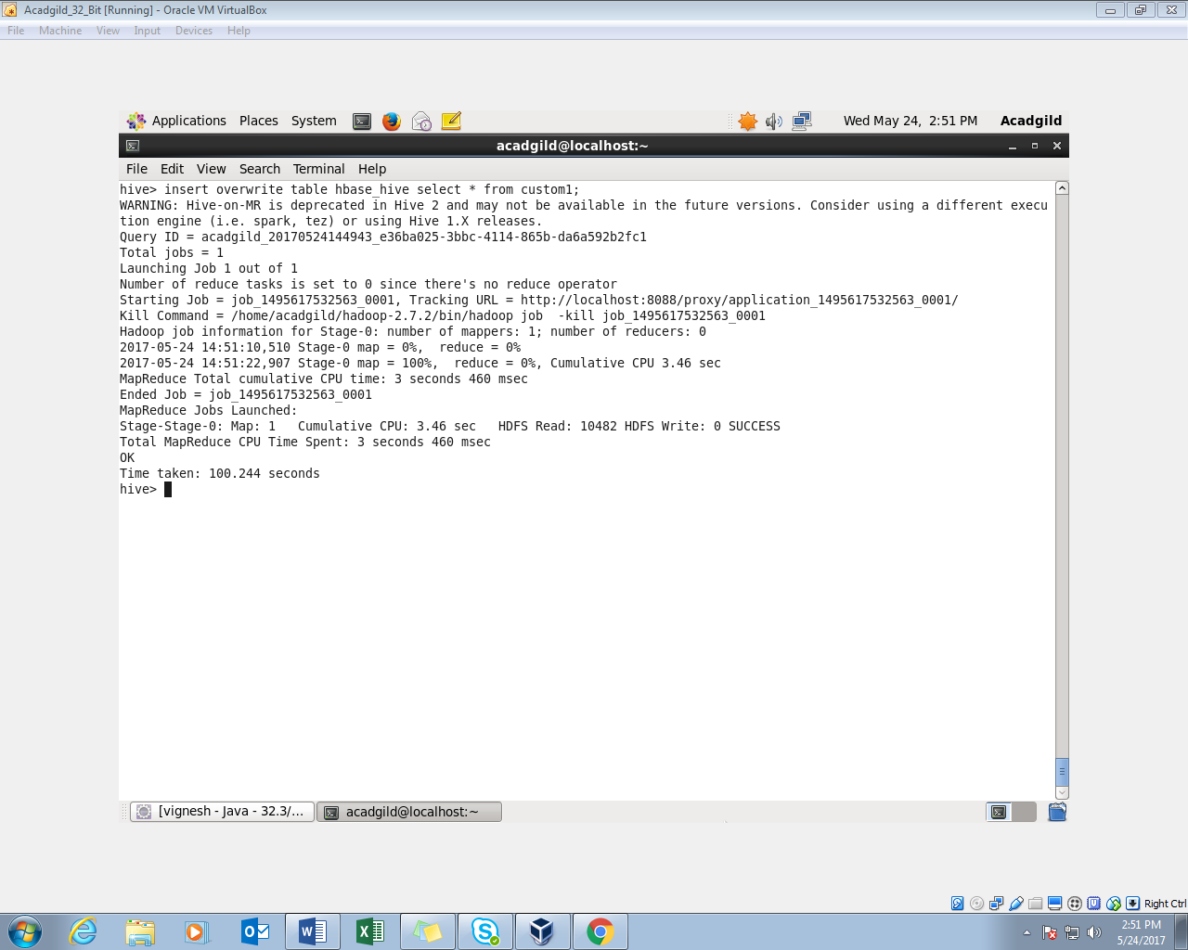

**Step 4: Data automatically gets transferred from hive to hbase**

